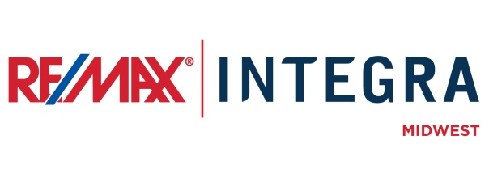

FOR IMMEDIATE RELEASE

FIRST LAST NAME WITH RE/MAX COMPANY NAME NAMED TOP AGENT

CITY, State. (Month ##, 2015) – [First last name] with RE/MAX [company] recently achieved Top Agent status by ranking on the RE/MAX INTEGRA, Midwest Top Agent Report for [month year].
The Top Agent Report is a monthly regional recognition and honors RE/MAX team leaders and individual real estate associates in [choose one: Indiana, Minnesota , Wisconsin] for month-over-month and year-to-date commissions earned and transactions closed.
[Last name] ranked ## for [choose one: individuals, team leaders] in [choose one: transactions closed, commissions earned] for [month of report].
[Last name] has been working in the real estate industry for more than ## years and has extensive experience in [list specialties]. Among [last name’s] achievements are [list other honors and achievements.]
[“First name] has been an integral member of our team and is more than deserving of this recognition,” said RE/MAX [company]’s broker/owner, [first last name.] “Achieving this status is a great accomplishment. [First name] continues to raise the bar in real estate, making us and this community proud.”

# # #
Contacts:
First Last
Broker/Owner, RE/MAX Company Name
(p) 612.555.5555 (e) name@email.com
About RE/MAX INTEGRA, Midwest
RE/MAX Office is affiliated with RE/MAX INTEGRA Midwest, which includes RE/MAX North Central in Minnesota and Wisconsin and RE/MAX of Indiana. Since its inception in 1985, the region has grown to more than 250 offices with approximately 3,700 sales associates, providing residential and commercial real estate, as well as relocation and referral services.
Integra Enterprises Corporation is a privately held company headquartered in Toronto, Ontario, Canada. Integra is the largest sub-franchisor of Denver, Colorado-based RE/MAX, LLC. Representing approximately 30 percent of RE/MAX worldwide with more than 27,000 agents, Integra operates RE/MAX regional headquarters in Massachusetts; Minnesota; Indiana; Toronto, Ontario, Canada; Vienna, Austria; and Zug, Switzerland. Integra’s proven operating model supports its membership with a highly accessible and responsive regional leadership team delivering proprietary business development, training, marketing, and event management services from each of its regional offices.

