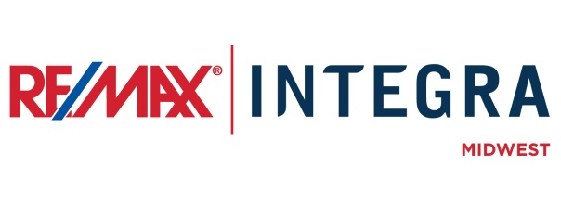

FOR IMMEDIATE RELEASE

RE/MAX Hot Air Balloon Rides Help Raise Funds For [Name of Cause]
CITY, State. (Month ##, 2015) – The iconic red, white and blue RE/MAX Hot Air Balloon recently made an appearance at the event held [Day, Month Date.]. The 80 foot tall hot air balloon was sponsored by RE/MAX [office] and offered tether rides to community members and event goers for donations benefiting [name of cause].
RE/MAX [office] has supported [name of cause] for [## years/months]. [Name of cause (add text explaining mission statement of cause, who benefits, etc.)]
[First Last Name], [broker/owner/agent] of RE/MAX [office], says supporting the cause and participating in the event is something the entire RE/MAX office enjoyed. [“place quote here.”]
RE/MAX [office] raised [nearly/more] than $## over the # day event and will present the [donation/contribution] to [name of cause] at [private meeting/check presentation] to be held on [month ## at name/address of location.]

# # #
Contacts:
First Last
Broker/Owner, RE/MAX Company Name
(p) 612.555.5555 (e) name@email.com
About RE/MAX INTEGRA, Midwest
RE/MAX Office is affiliated with RE/MAX INTEGRA Midwest, which includes RE/MAX North Central in Minnesota and Wisconsin and RE/MAX of Indiana. Since its inception in 1985, the region has grown to more than 250 offices with approximately 3,700 sales associates, providing residential and commercial real estate, as well as relocation and referral services.
Integra Enterprises Corporation is a privately held company headquartered in Toronto, Ontario, Canada. Integra is the largest sub-franchisor of Denver, Colorado-based RE/MAX, LLC. Representing approximately 30 percent of RE/MAX worldwide with more than 27,000 agents, Integra operates RE/MAX regional headquarters in Massachusetts; Minnesota; Indiana; Toronto, Ontario, Canada; Vienna, Austria; and Zug, Switzerland. Integra’s proven operating model supports its membership with a highly accessible and responsive regional leadership team delivering proprietary business development, training, marketing, and event management services from each of its regional offices.

