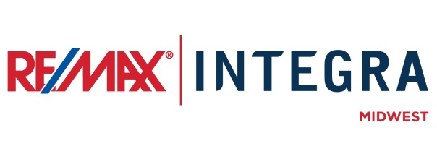

FOR IMMEDIATE RELEASE

RE/MAX Hot Air Balloon to give Tether Rides at [Name of Event]
CITY, State. (Month ##, 2015) – RE/MAX [OFFICE NAME]’s Broker/Owners and Associates are excited to announce that the iconic seven-story red, white, and blue RE/MAX Hot Air Balloon will be a main attraction at [NAME OF EVENT].
Wind and weather permitting, RE/MAX [OFFICE NAME] will host hot air balloon tether rides at [LOCATION] in [CITY, STATE] on [DATE] from approximately [TIME]. Event attendees age 10 years and up are welcome to experience the RE/MAX Hot Air Balloon by riding 30-40 feet “Above the Crowd” in the balloon basket.
Optional Quote:
“We are excited to sponsor this unique experience at [name of event]” said RE/MAX [OFFICE NAME] [AGENT/OWENR] [NAME]. “[INSERT PERSONAL QUOTE IF DESIRED].”

# # #
Contacts:
First Last
Broker/Owner, RE/MAX Company Name
(p) 612.555.5555 (e) name@email.com
About RE/MAX INTEGRA, Midwest
RE/MAX Office is affiliated with RE/MAX INTEGRA Midwest, which includes RE/MAX North Central in Minnesota and Wisconsin and RE/MAX of Indiana. Since its inception in 1985, the region has grown to more than 250 offices with approximately 3,700 sales associates, providing residential and commercial real estate, as well as relocation and referral services.
Integra Enterprises Corporation is a privately held company headquartered in Toronto, Ontario, Canada. Integra is the largest sub-franchisor of Denver, Colorado-based RE/MAX, LLC. Representing approximately 30 percent of RE/MAX worldwide with more than 27,000 agents, Integra operates RE/MAX regional headquarters in Massachusetts; Minnesota; Indiana; Toronto, Ontario, Canada; Vienna, Austria; and Zug, Switzerland. Integra’s proven operating model supports its membership with a highly accessible and responsive regional leadership team delivering proprietary business development, training, marketing, and event management services from each of its regional offices.

