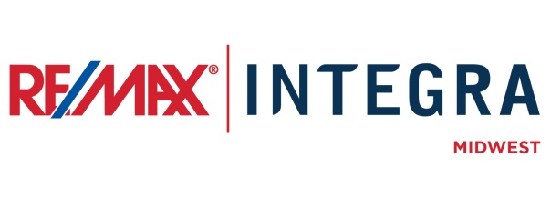

FOR IMMEDIATE RELEASE

RE/MAX Associate [First Last Name] Recognized as ‘Realtor of the Year’ by [Association Name]
CITY, State. (Month ##, 2015) – RE/MAX [office] in [city] is pleased to announce that Associate [First Last name] has been presented the [year] [choose one: Indiana, Minnesota, Wisconsin] Realtor of the Year by the [Association name][(abbreviation if applicable)].
[Association abbreviation] recognized [last name] with this prestigious award for demonstrating extraordinary service to [his/her] community and for [his/her] outstanding achievements in the real estate industry.
“No one is more deserving of this award than [first last name],” said [first last name], broker/owner of RE/MAX [office]. “We’re proud of [his/her] hard work not only with the clients [he/she] serves, but also for [his/her] leadership role in the real estate industry. We are thrilled to see [him/her] recognized for [his/her] many years of excellence and success.”
The annual Realtor of the Year award is granted by a committee of [association abbreviation] members from across the state that considers nominations made by ## local REALTOR® associations in [choose one: Indiana, Minnesota, Wisconsin]. The award is the highest honor recognizing members for their dedication to civic, business, and industry-related activities and achievements.
[Last name] brings more than ## years of experience as a real estate professional, specializing in the marketing and sale of [residential, commercial, lakefront, land development, etc.] properties in [name of greater service area].

# # #
Contacts:
First Last
Broker/Owner, RE/MAX Company Name
(p) 612.555.5555 (e) name@email.com
About RE/MAX INTEGRA, Midwest
RE/MAX Office is affiliated with RE/MAX INTEGRA Midwest, which includes RE/MAX North Central in Minnesota and Wisconsin and RE/MAX of Indiana. Since its inception in 1985, the region has grown to more than 250 offices with approximately 3,700 sales associates, providing residential and commercial real estate, as well as relocation and referral services.
Integra Enterprises Corporation is a privately held company headquartered in Toronto, Ontario, Canada. Integra is the largest sub-franchisor of Denver, Colorado-based RE/MAX, LLC. Representing approximately 30 percent of RE/MAX worldwide with more than 27,000 agents, Integra operates RE/MAX regional headquarters in Massachusetts; Minnesota; Indiana; Toronto, Ontario, Canada; Vienna, Austria; and Zug, Switzerland. Integra’s proven operating model supports its membership with a highly accessible and responsive regional leadership team delivering proprietary business development, training, marketing, and event management services from each of its regional offices.

