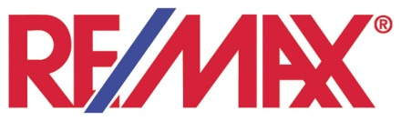
Company Name Here

FOR IMMEDIATE RELEASE
Headline
Summary line
CITY, MINN. – (Date) – Paragraph one: who, what, when, where, why.
Paragraph two: describes in further detail what and why.
Paragraph three: quote supporting what or why.
Paragraph four: use as needed with further details.
# # #
CONTACTS:
Broker/Agent Name  Title, Broker Office  (p) Phone (e) E-mail | Broker/Agent Name  Title, Broker Office  (p) Phone (e) E-mail

About RE/MAX ---------------

RE/MAX ------ is affiliated with RE/MAX INTEGRA, Midwest, the regional body for RE/MAX franchises throughout Indiana, Minnesota, and Wisconsin, and RE/MAX, LLC. RE/MAX was founded in 1973 in Denver, Colorado by Dave and Gail Liniger. It has grown to a global network of more than 90,000 Sales Associates in more than 90 countries. No one sells more real estate than RE/MAX.

