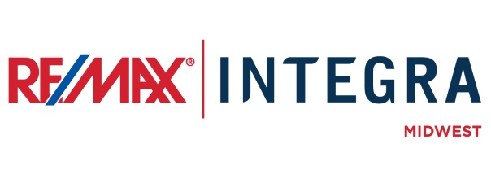

FOR IMMEDIATE RELEASE

RE/MAX [COMPANY] Welcomes New Sales Associate

CITY, State. (Month ##, 2015) – Potential home buyers and sellers in [city] can now benefit from the real estate services of [first last name], who recently joined RE/MAX [company] as a Sales Associate.
[Last name] has been in the real estate industry for ## years. [He/She] has served clients in [name of counties, cities, or greater service area] and is experienced in [list specializations: (residential, commercial, lakefront, land development, etc.)]
[Last name} says, “QUOTE REASON TO JOIN RE/MAX.”
[Last name] holds [list designations] and participates in [list charity involvement or industry/business involvement. ]
# # #
Contacts:
First Last
Broker/Owner, RE/MAX Company Name
(p) 612.555.5555 (e) name@email.com
About RE/MAX INTEGRA, Midwest
RE/MAX Office is affiliated with RE/MAX INTEGRA Midwest, which includes RE/MAX North Central in Minnesota and Wisconsin and RE/MAX of Indiana. Since its inception in 1985, the region has grown to more than 250 offices with approximately 3,700 sales associates, providing residential and commercial real estate, as well as relocation and referral services.
Integra Enterprises Corporation is a privately held company headquartered in Toronto, Ontario, Canada. Integra is the largest sub-franchisor of Denver, Colorado-based RE/MAX, LLC. Representing approximately 30 percent of RE/MAX worldwide with more than 27,000 agents, Integra operates RE/MAX regional headquarters in Massachusetts; Minnesota; Indiana; Toronto, Ontario, Canada; Vienna, Austria; and Zug, Switzerland. Integra’s proven operating model supports its membership with a highly accessible and responsive regional leadership team delivering proprietary business development, training, marketing, and event management services from each of its regional offices.

