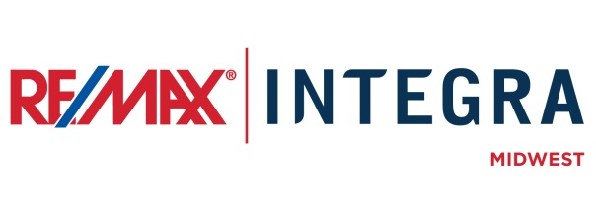

FOR IMMEDIATE RELEASE

ASSOCIATES AT RE/MAX [OFFICE] BECOME CHILDREN’S MIRACLE NETWORK CONTRIBUTORS
CITY, State. (Month ##, 2015) – [First Last Name], Broker/Owner of RE/MAX [office], is pleased to announce that the following associates with RE/MAX [office] have decided to become a Children’s Miracle Network, Miracle Home Associates: [list agents].
RE/MAX Miracle Home Associates have committed to donate a portion of their commissions to their Children’s Miracle Network Hospital. Locally, all donations benefit [choose one: Gillette Children’s Specialty Healthcare, Children’s Hospital of Wisconsin, Gundersen Health System, Ministry St. Joseph’s Hospital, Children’s Hospital of Chicago, Children’s Medical Center of Dayton, Cincinnati Children’s Hospital, Riley Hospital for Children].
RE/MAX LLC has been a proud national sponsor of Children’s Miracle Network Hospitals since 1992. Since that time, RE/MAX agents and offices have raised over $130 million for children’s hospitals throughout North America.

# # #
Contacts:
First Last
Broker/Owner, RE/MAX Company Name
(p) 612.555.5555 (e) name@email.com
About RE/MAX INTEGRA, Midwest
RE/MAX Office is affiliated with RE/MAX INTEGRA Midwest, which includes RE/MAX North Central in Minnesota and Wisconsin and RE/MAX of Indiana. Since its inception in 1985, the region has grown to more than 250 offices with approximately 3,700 sales associates, providing residential and commercial real estate, as well as relocation and referral services.
Integra Enterprises Corporation is a privately held company headquartered in Toronto, Ontario, Canada. Integra is the largest sub-franchisor of Denver, Colorado-based RE/MAX, LLC. Representing approximately 30 percent of RE/MAX worldwide with more than 27,000 agents, Integra operates RE/MAX regional headquarters in Massachusetts; Minnesota; Indiana; Toronto, Ontario, Canada; Vienna, Austria; and Zug, Switzerland. Integra’s proven operating model supports its membership with a highly accessible and responsive regional leadership team delivering proprietary business development, training, marketing, and event management services from each of its regional offices.

