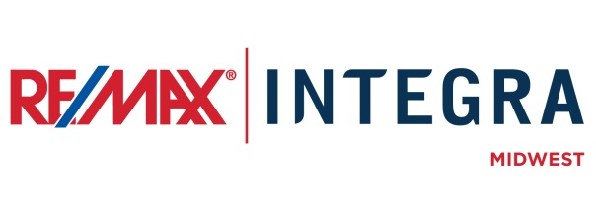

FOR IMMEDIATE RELEASE

RE/MAX Hot Air Balloon to Appear at Children’s Miracle Network Fundraiser
CITY, State. (Month ##, 2015) – RE/MAX [office]’s Broker/Owners and Associates are excited to announce an upcoming fundraiser supporting Children’s Miracle Network (CMN), which the seven-story red, white, and blue RE/MAX hot air balloon will be a main attraction, and community members are invited to attend.
RE/MAX [office] will host [event name] at [location] in [city, state] on [date]. The RE/MAX Hot Air Balloon will be, weather permitting, [choose one: giving tether rides, flying over, appearing in the parade] from [timeframe].
The RE/MAX [event name] is [insert description of event to include fundraising efforts (how money is raised for CMN), people involved, other donors, etc.]

# # #
Contacts:
First Last
Broker/Owner, RE/MAX Company Name
(p) 612.555.5555 (e) name@email.com
About RE/MAX INTEGRA, Midwest
RE/MAX Office is affiliated with RE/MAX INTEGRA Midwest, which includes RE/MAX North Central in Minnesota and Wisconsin and RE/MAX of Indiana. Since its inception in 1985, the region has grown to more than 250 offices with approximately 3,700 sales associates, providing residential and commercial real estate, as well as relocation and referral services.
Integra Enterprises Corporation is a privately held company headquartered in Toronto, Ontario, Canada. Integra is the largest sub-franchisor of Denver, Colorado-based RE/MAX, LLC. Representing approximately 30 percent of RE/MAX worldwide with more than 27,000 agents, Integra operates RE/MAX regional headquarters in Massachusetts; Minnesota; Indiana; Toronto, Ontario, Canada; Vienna, Austria; and Zug, Switzerland. Integra’s proven operating model supports its membership with a highly accessible and responsive regional leadership team delivering proprietary business development, training, marketing, and event management services from each of its regional offices.

